24.31: a) 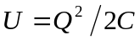
The number of electrons N that must be removed from one plate and added to the other is electrons.
b) To double
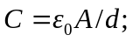 halve the plate area or double the plate separation.

